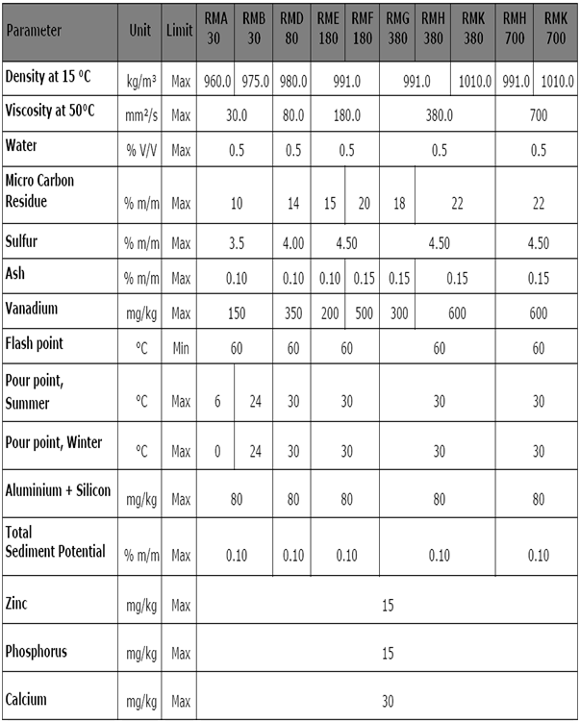
ISO 8217: 2005 - Specifications of Marine Fuels

