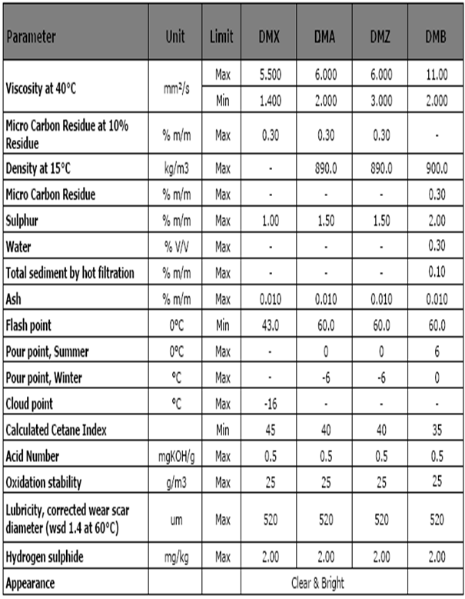
ISO 8217: 2010 - Specifications of Marine Distillate Fuels

